Test Case: tc001_SPX_Dev5_Crear_Solicitud_Articulo_Almacen
Step 1 - Enter username and password and click to button Enter : Credentials Entered
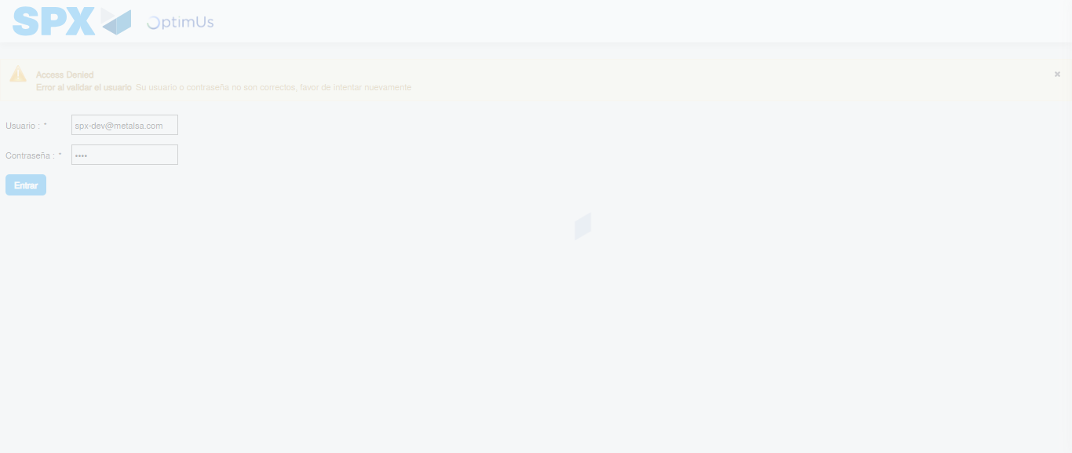Image file-name: QC_Testing-tc001_SPX_Dev5_Crear_Solicitud_Articulo_Almacen-1787864221970

Step 2 - Select to UEN and Access to Request for a New Inventory Item : UEN Correctly selected and Correct access
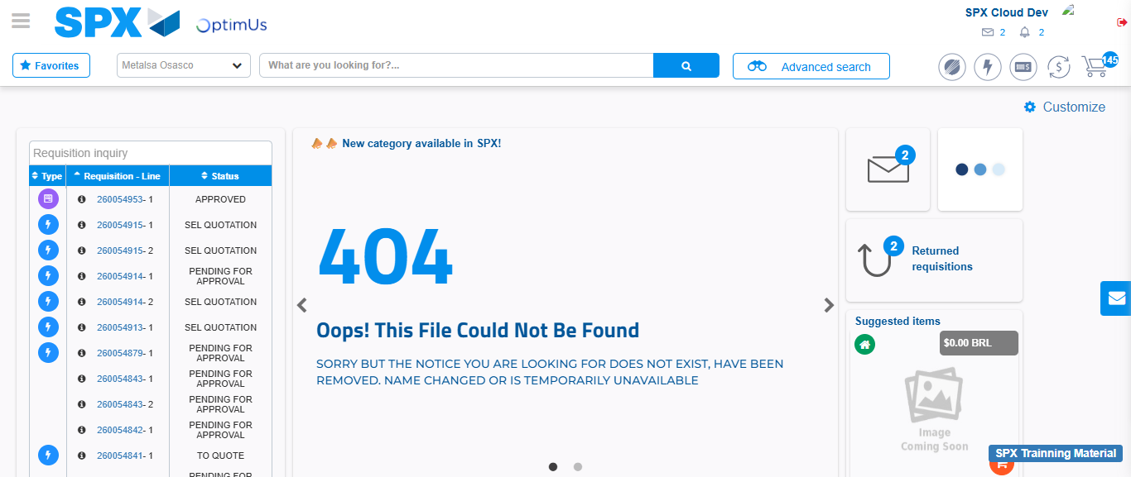Image file-name: QC_Testing-tc001_SPX_Dev5_Crear_Solicitud_Articulo_Almacen-1787864251118

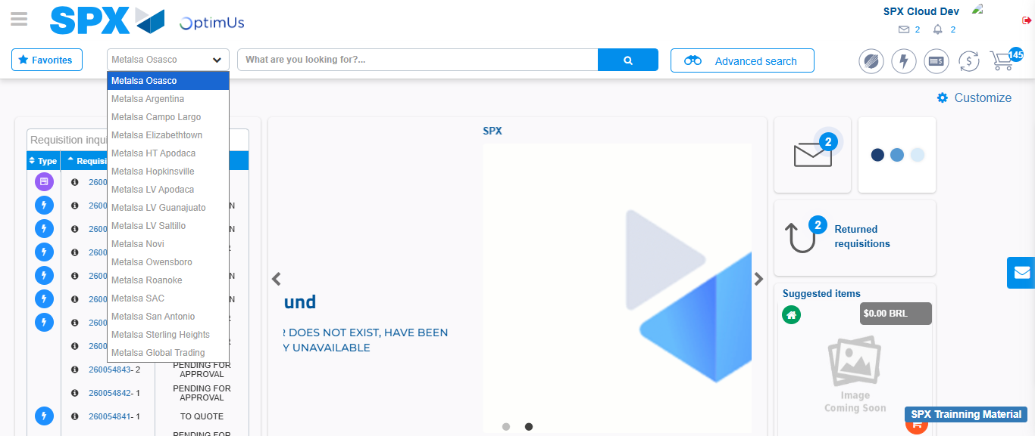Image file-name: QC_Testing-tc001_SPX_Dev5_Crear_Solicitud_Articulo_Almacen-1787864251730

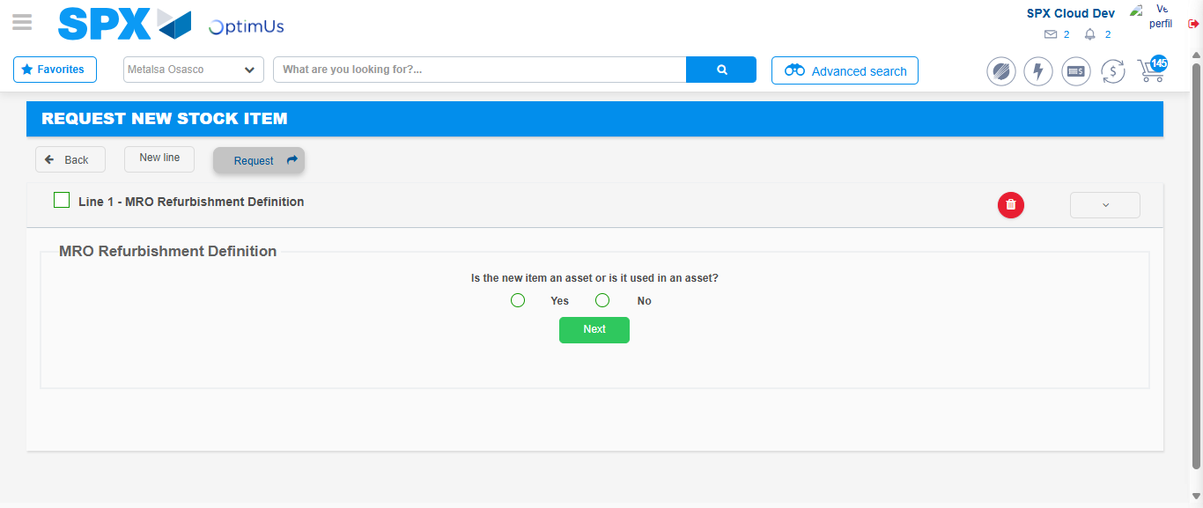Image file-name: QC_Testing-tc001_SPX_Dev5_Crear_Solicitud_Articulo_Almacen-1787864283252

Step 3 - Select options first section : Options seleted correctly
Image file-name: QC_Testing-tc001_SPX_Dev5_Crear_Solicitud_Articulo_Almacen-1787864283460

Image file-name: QC_Testing-tc001_SPX_Dev5_Crear_Solicitud_Articulo_Almacen-1787864283645

Step 4 - Select options at Screen: Options seleted correctly
Image file-name: QC_Testing-tc001_SPX_Dev5_Crear_Solicitud_Articulo_Almacen-1787864283460

Image file-name: QC_Testing-tc001_SPX_Dev5_Crear_Solicitud_Articulo_Almacen-1787864283645

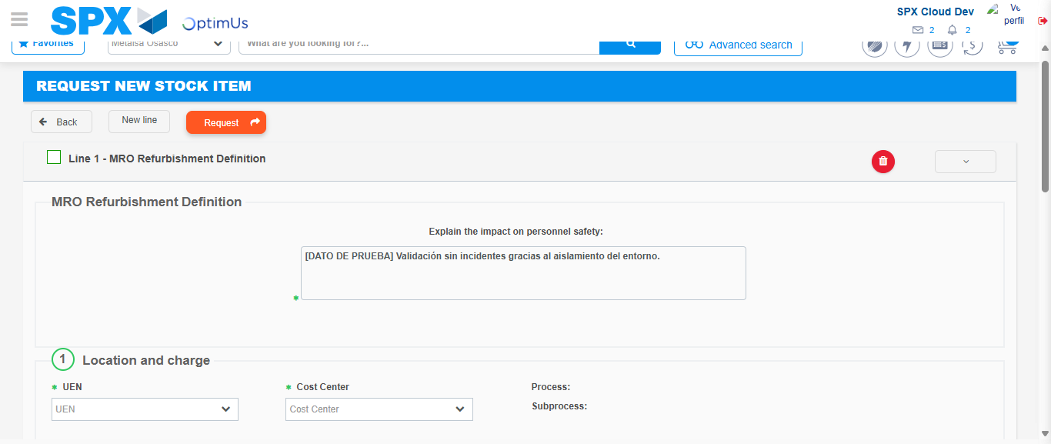Image file-name: QC_Testing-tc001_SPX_Dev5_Crear_Solicitud_Articulo_Almacen-1787864289445

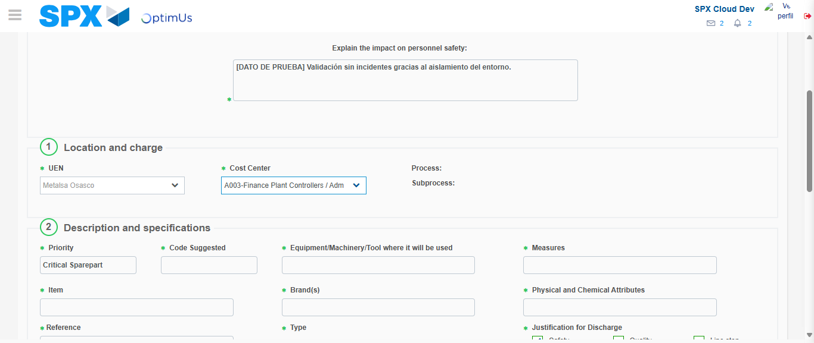Image file-name: QC_Testing-tc001_SPX_Dev5_Crear_Solicitud_Articulo_Almacen-1787864291802

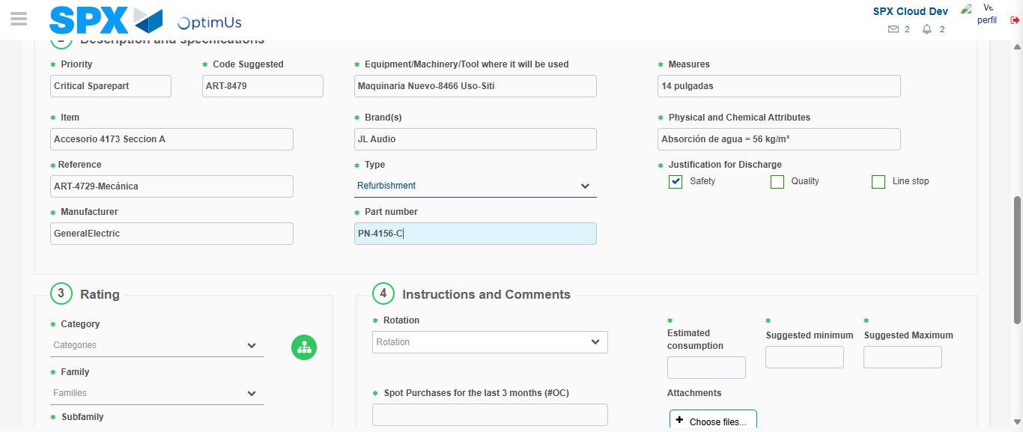Image file-name: QC_Testing-tc001_SPX_Dev5_Crear_Solicitud_Articulo_Almacen-1787864293148

Step 7 - Return to Main Page SPX : Return to Main Page SPX
Image file-name: QC_Testing-tc001_SPX_Dev5_Crear_Solicitud_Articulo_Almacen-1787864251118

Image file-name: QC_Testing-tc001_SPX_Dev5_Crear_Solicitud_Articulo_Almacen-1787864251730

Image file-name: QC_Testing-tc001_SPX_Dev5_Crear_Solicitud_Articulo_Almacen-1787864283252

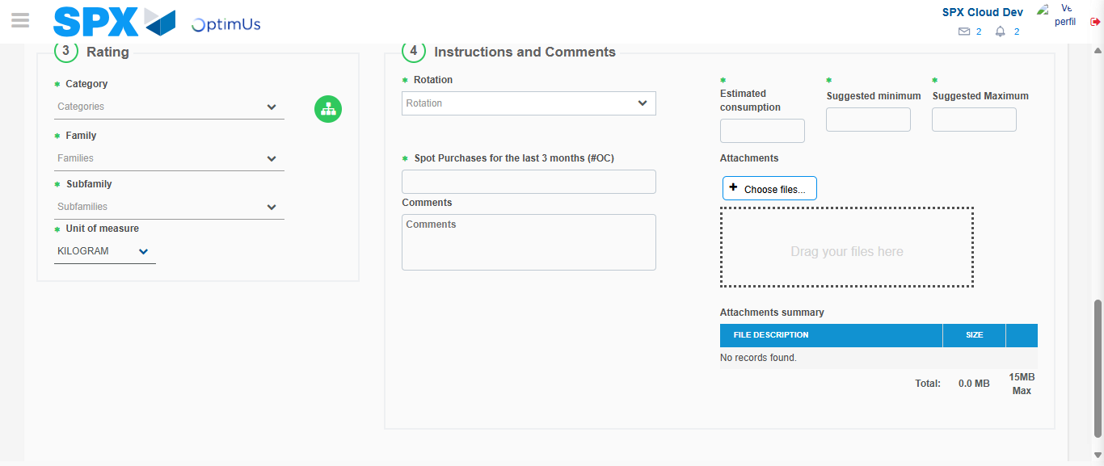Image file-name: QC_Testing-tc001_SPX_Dev5_Crear_Solicitud_Articulo_Almacen-1787864296880

Image file-name: QC_Testing-tc001_SPX_Dev5_Crear_Solicitud_Articulo_Almacen-1787864297032

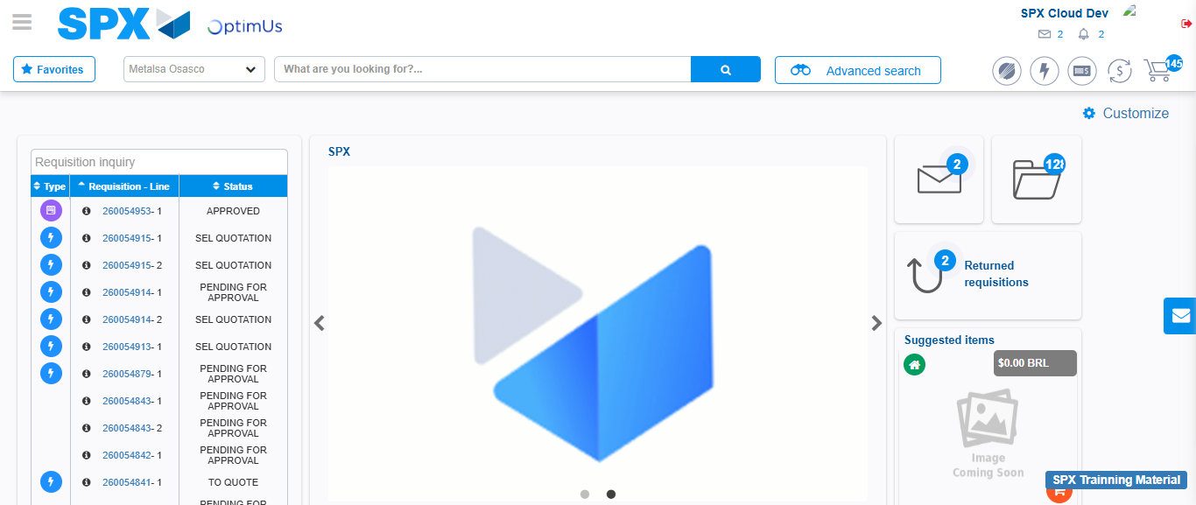Image file-name: QC_Testing-tc001_SPX_Dev5_Crear_Solicitud_Articulo_Almacen-1787864318032

Step 8 - Log Out : Log Out SPX
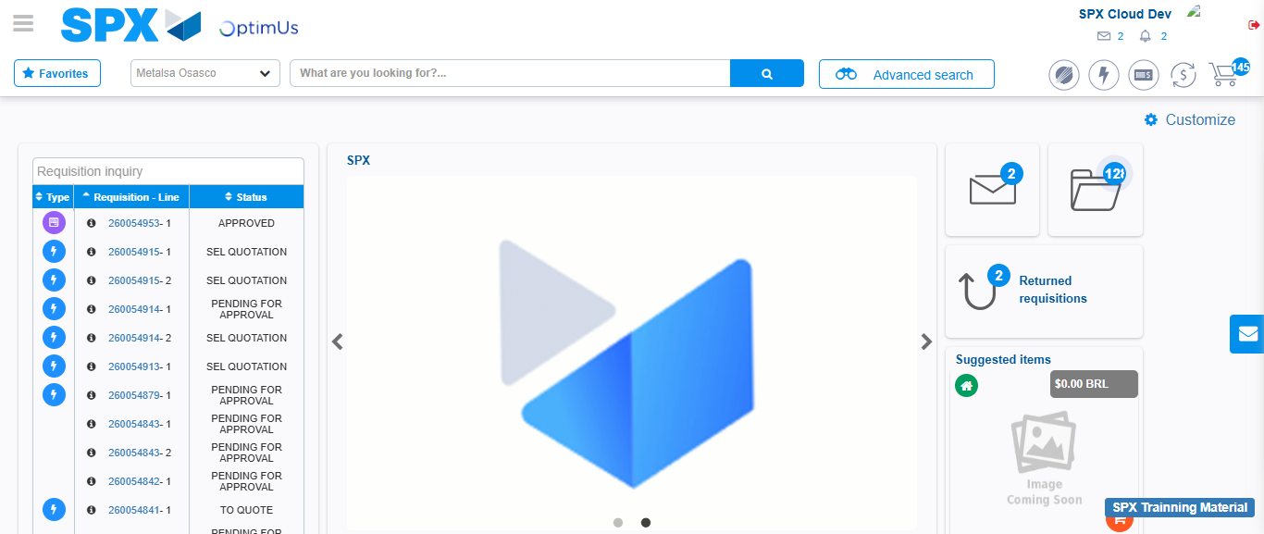Image file-name: QC_Testing-tc001_SPX_Dev5_Crear_Solicitud_Articulo_Almacen-1787864318303

